CS 255 System Design Document

UML Diagrams

UML Use Case Diagram
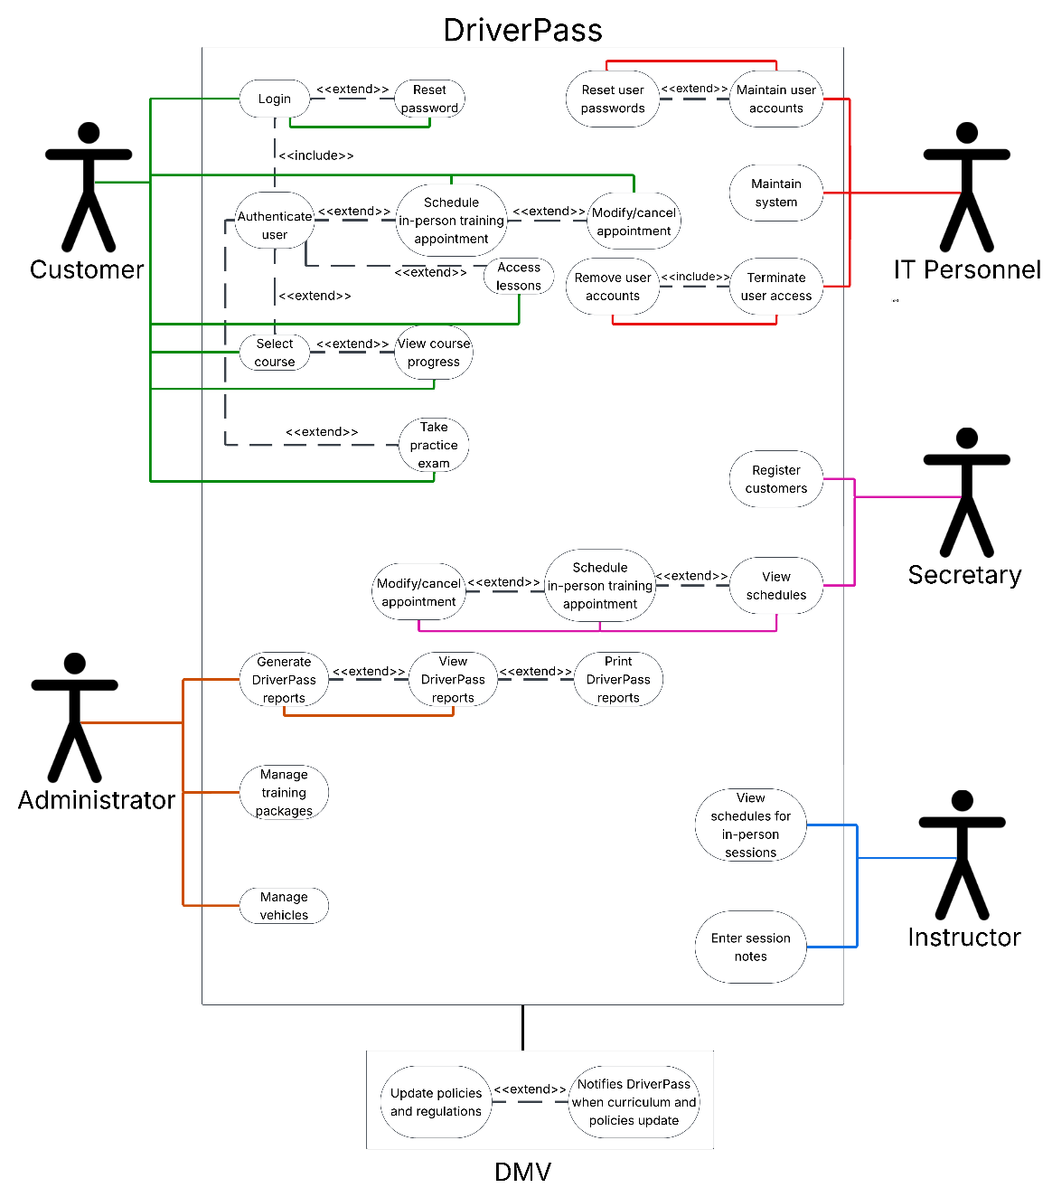
This use case diagram shows the different actors within DriverPass’s system. Each actor is assigned to a use case, which shows how each actor interacts with the system. Some use cases within this diagram have included or extended use cases, where included indicates a required step in the system, while extend indicates an optional step.

UML Activity Diagrams
These two activity diagrams show the processes between the customer and DriverPass system. The first UML activity diagram shows how the customer schedules an in-person driving training session and how the processes between the customer and system work together to successfully schedule an appointment. The second UML activity diagram shows how the customer can modify or cancel their appointment by illustrating the workflow and decisions to either modify the appointment date and time or cancel the appointment.
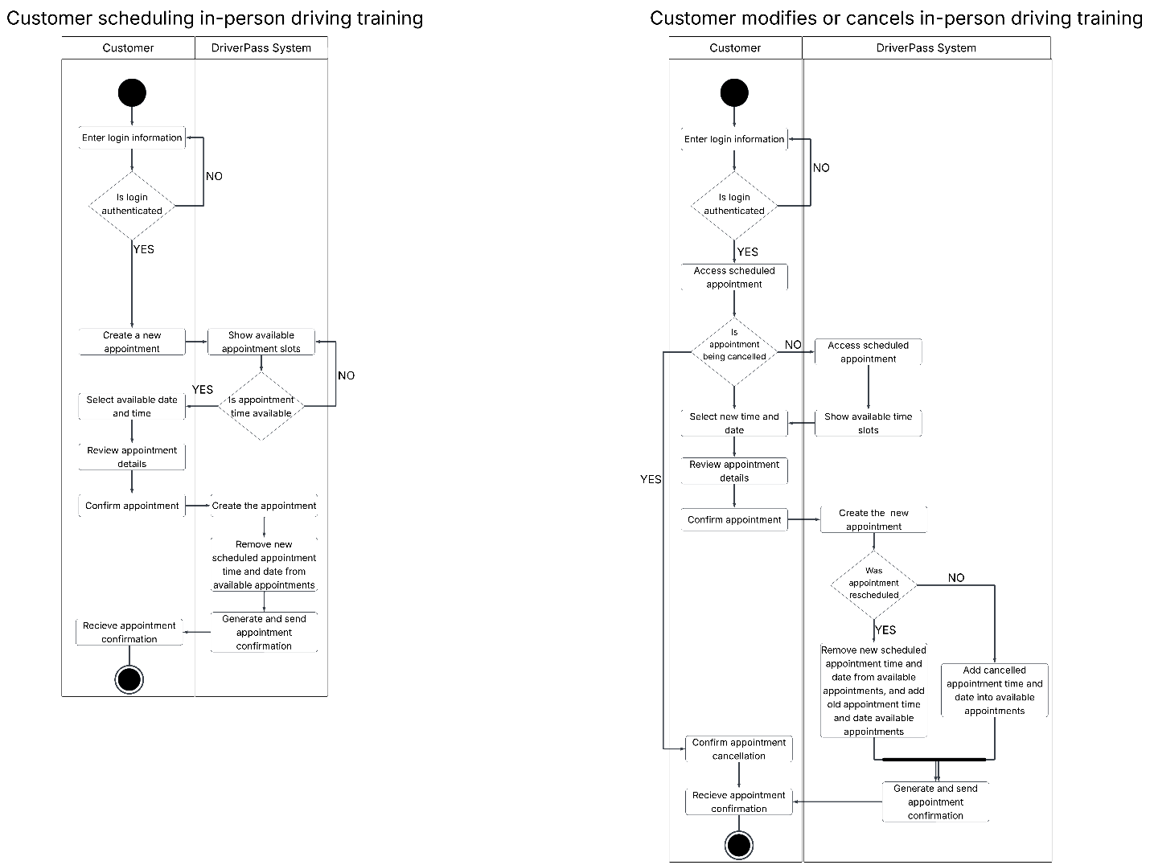

UML Sequence Diagram
This sequence diagram shows the sequence of events that occur when a customer calls to register their account with DriverPass. The customer calls the secretary who fills out a form with the customer’s information and payment details. This form is then validated in the DriverPass’s system, and once validated, stored in the customer database. The system will then notify the secretary that the user registration is complete, and the secretary completes the registration with the customer.
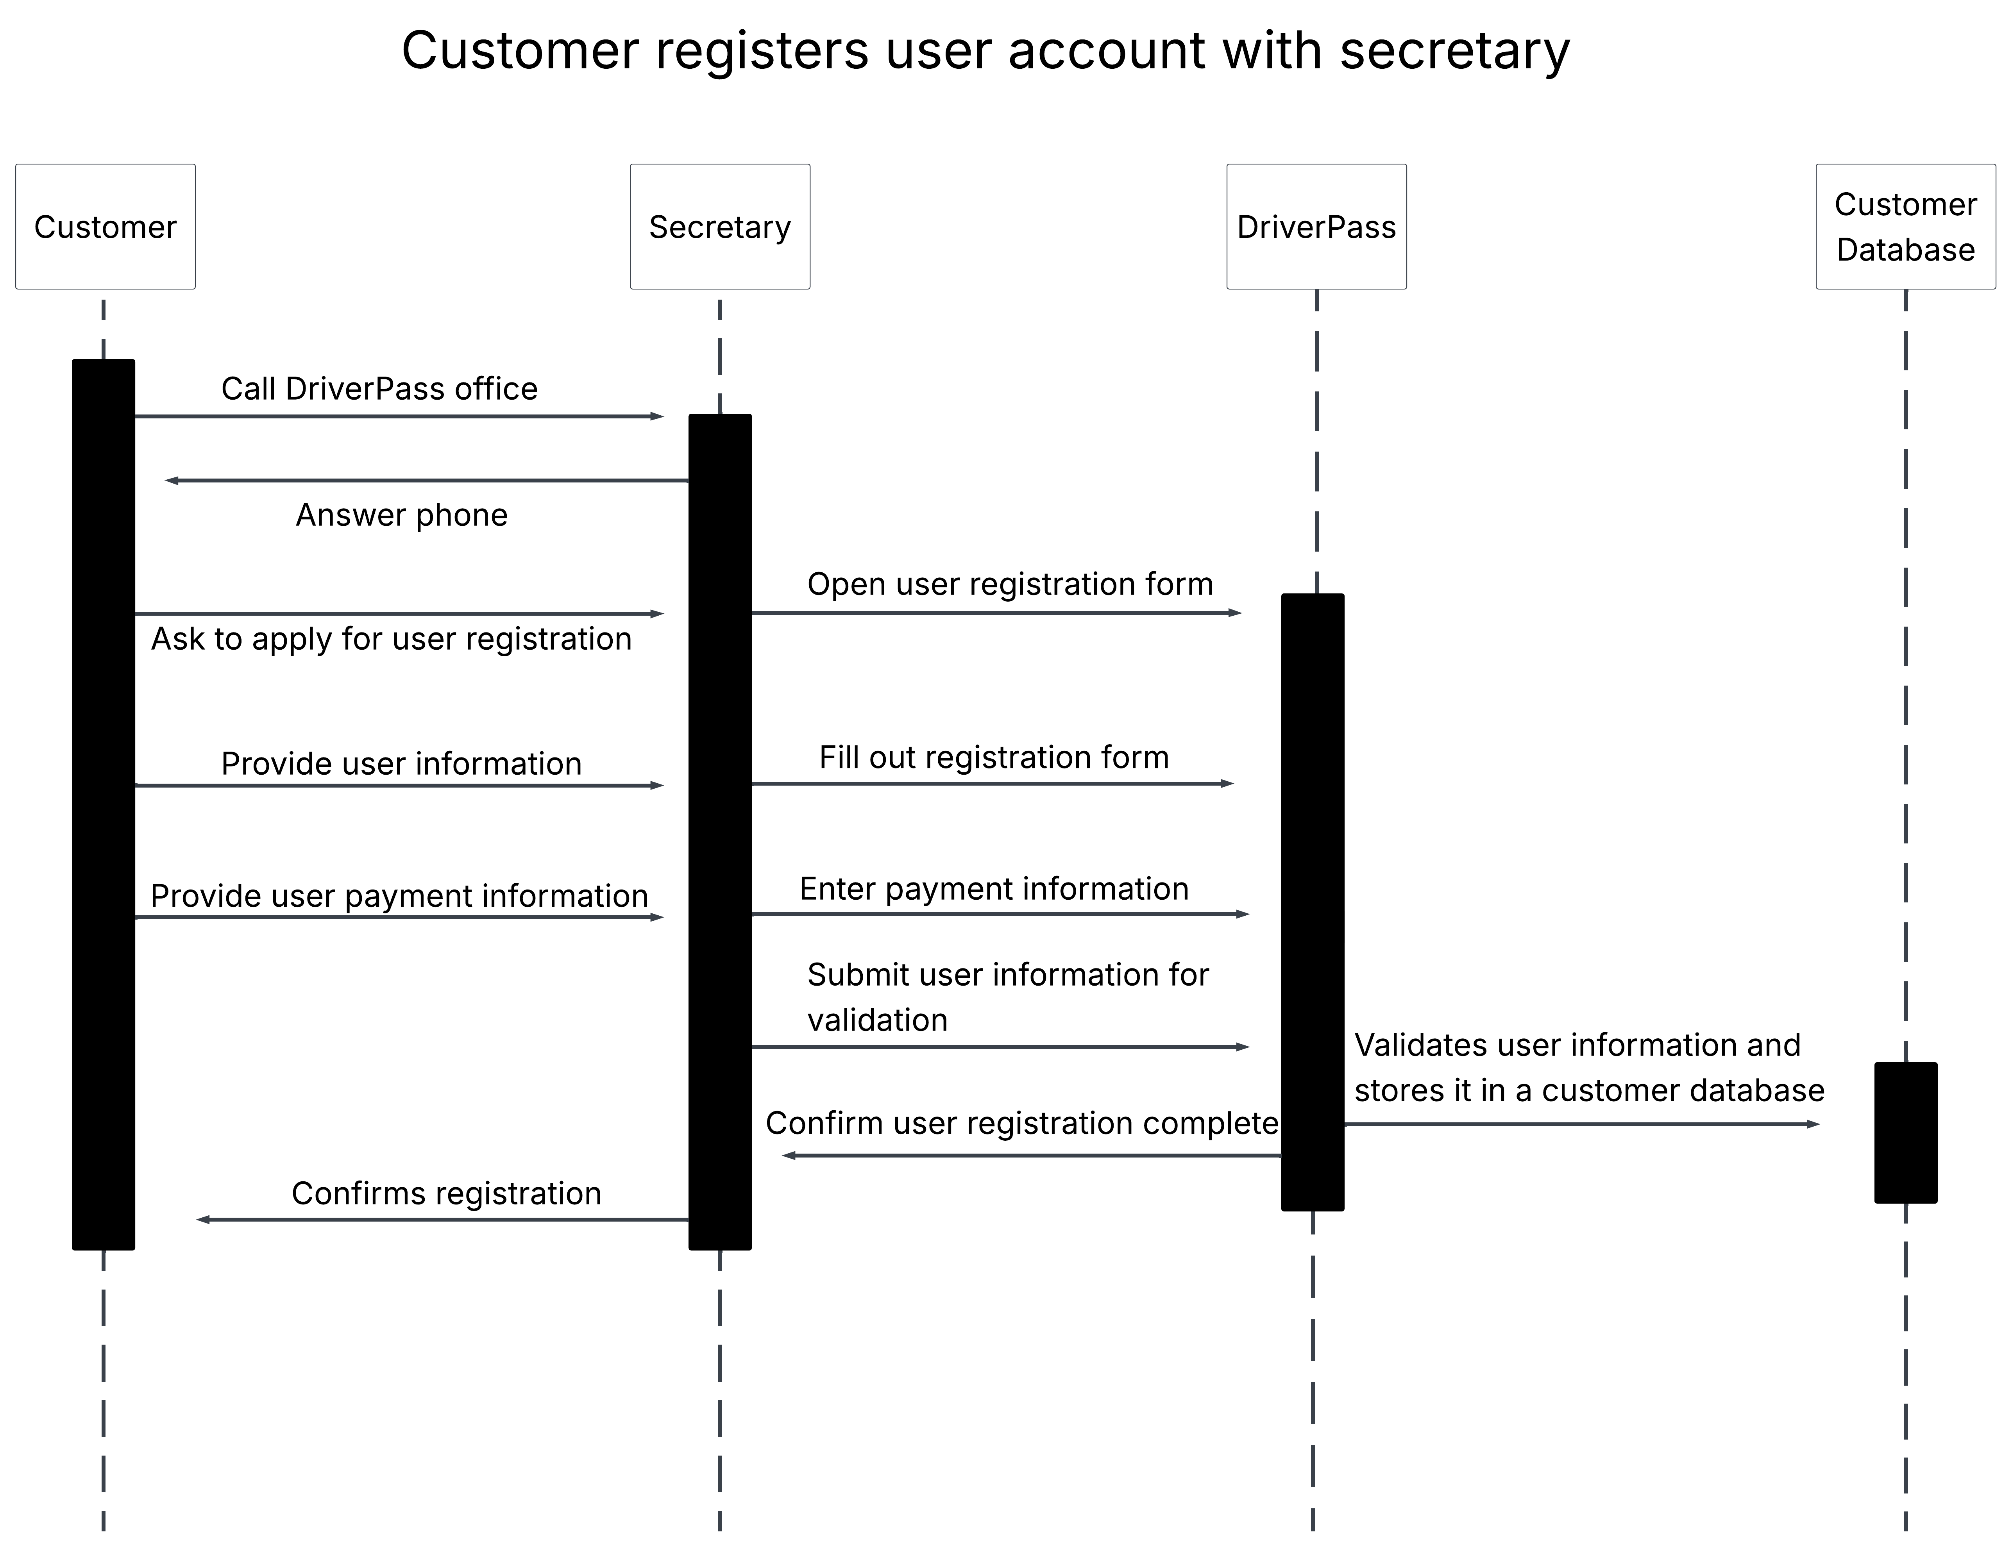

UML Class Diagram
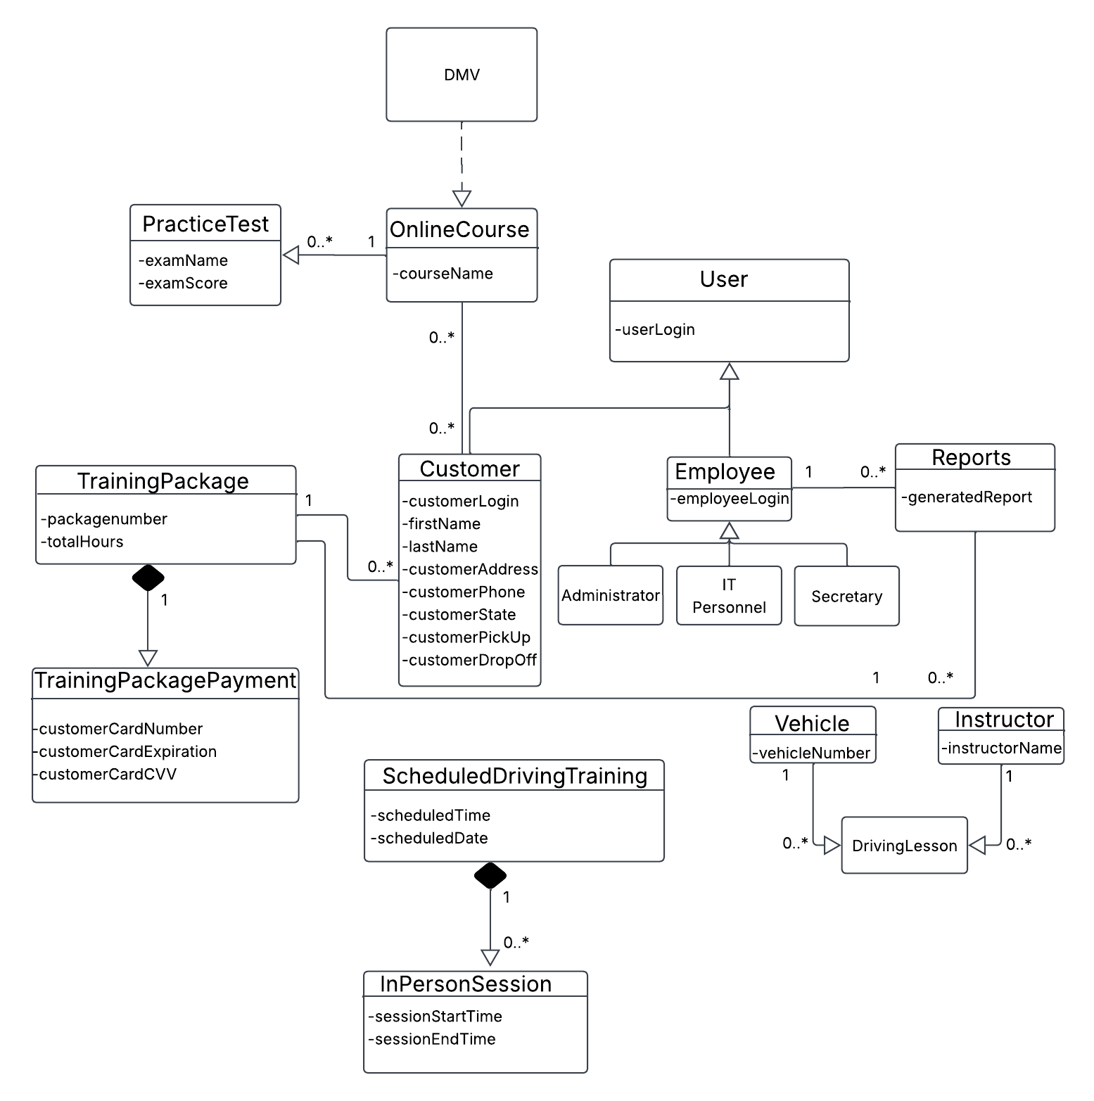
This class diagram includes the classes, attributes, and their relationships with one another. A user class inherits from Customer and Employee classes, with Employee objects divided into Administrator, IT Personnel, and Secretary. This diagram also outlines several objects that are related to the Customer class, as well as a Report class that will store generated reports from the system. The system also relies on an external DMV system to receive the updates to the OnlineCourse.

Technical Requirements
Based on the transcript and previously completed business requirements document, I have identified several technical requirements to create a successful system design for DriverPass. The system is required to be deployed on a cloud-based infrastructure, that can be maintained by the cloud-based host rather than DriverPass entirely. This should also be scalable to support a growing user base. DriverPass’s system is also web-based, meaning that users need to access the system through a device, such as a tablet, mobile phone, or laptop; this device also needs to be able to connect to the internet and be able to access an internet browser. The cloud-based host will be responsible for storing and securing payment information. As well as securing payment information, this hosting service should also provide an authentication system to validate user log in credentials.
DriverPass’s system should also allow users to reset their passwords themselves. This system is also role-based, which allows users to play a certain role in the system, such as Administrators, only get access to the appropriate data and processes in the system. For example, Customers will not be able to terminate other user’s access, but a user that logs in with an IT Personnel credential will be able to. For the system to be up to date with regulations and policies for driver education, integration with an external DMV will be needed. This integration should also notify the DriverPass system upon these updates.

